CSC413 – Survey of Programming Languages
Evolution Case Study with Mini Prototype
Henry Okwudili
MAT NO: 22120613031
400LVL Computer Science Stream 1
Abstract
This study explores the evolution of programming language design by carrying out a comparative analysis of C and Python, focusing on their data types, variable binding, scope rules, and semantics. The C programming language has static memory management and gives detailed control of memory to the programmer but lacks flexibility. Python, on the other hand, uses dynamic memory management where it abstracts memory management, taking care of it behind the scenes, to improve developer productivity. The study uses a comparative methodology to analyse the syntax difference and introduces a mini-prototype carried out in C. This prototype uses C to show Python’s ability to increase the size of a list automatically by using the realloc() function. This prototype shows how low-level static blocks can be used to create high-level dynamic features. The results of the prototype show the trade-off between performance in C and Python’s abstraction demonstrating how manual memory management has evolved.
- Introduction
The evolution of programming languages shows the shift from machine focused optimisation to human focused abstraction. C, developed in the 1972, was designed to align closely to hardware instructions. This required programmers to manage memory allocation manually and explicitly define data types. More modern languages like Python, developed in 1991, automate this memory management process in order to prioritise readability and fast development.
This study analyses C and Python’s evolution in handling:
- Data Types: From explicit to implicit definition.
- Variable Binding: From fixed memory locations to object references.
- Scope Rules: From strict block scoping to function-level scoping.
Understanding this evolution reveals the “cost” of abstraction where, while Python is easier to write than C it hides the complex operations that C exposes to programmers.

- Methodology
  - Comparative Framework
To measure how each language handles variable definition and scope, this study compares, side-by-side, the codes of each language. These are what are analysed:
- Static vs. Dynamic Typing: This study analyses how variables behave when assigned different data types.
- Scope: This study analyses how variable visibility changes inside control structures.
2.2 Code Demonstration
  - Data Types (Explicit vs. Implicit): C is explicitly typed, the variable’s data type is manually declared by the programmer while Python can infer the type from the value (Implicit declaration).
    - C Code (Explicit): 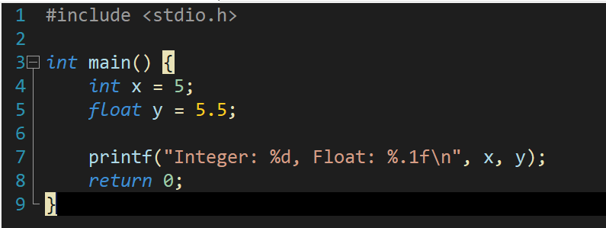
    - Python Code (Implicit): 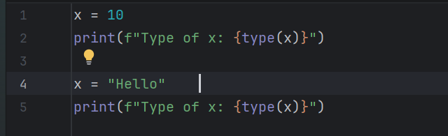
  - Variable Binding and Lifetime: In C the variables are Stack-Dynamic meaning they are bound when the function starts and destroyed (i.e., the lifetime ends) when the function returns. The storage is allocated on the run-time stack when a function starts execution while in Python the variables are Implicit Heap-Dynamic meaning they are created on the heap and remain as long as they are needed (Garbage Collection).
    - C Code (Stack Lifetime): 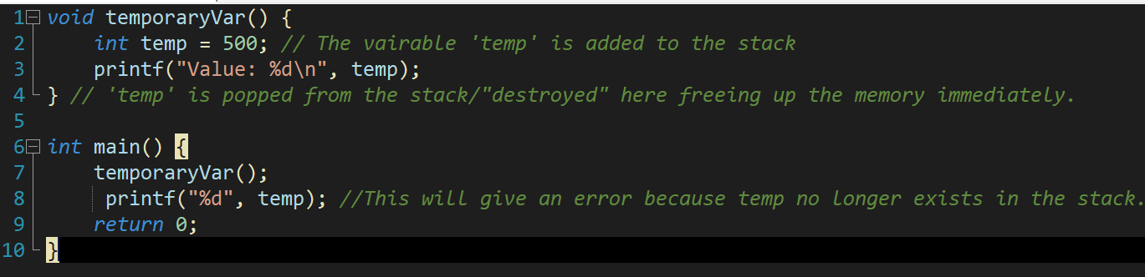
    - Python Code (Heap Lifetime): 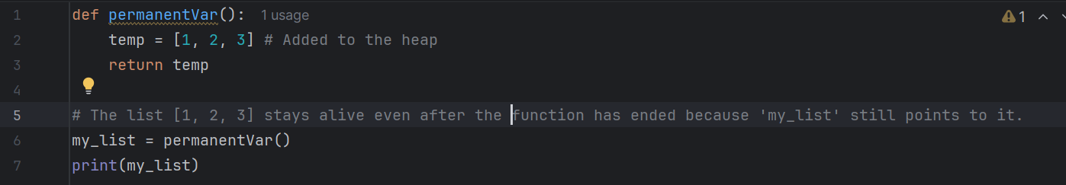
  - Scope Rules (Block vs. Leaking): C uses what is called a Block Scope meaning that the variables declared within the block (defined with { }) die at the closing brace ‘}’. Python uses the Lexical Scope where a variable’s scope is determined by its position in the code and not by where or when a function is called during runtime, but it allows variables to leak out of control structures like if or for meaning that even after the control structure has finished executing the variable can still be accessed.
    - C Code (Strict Block Scope): 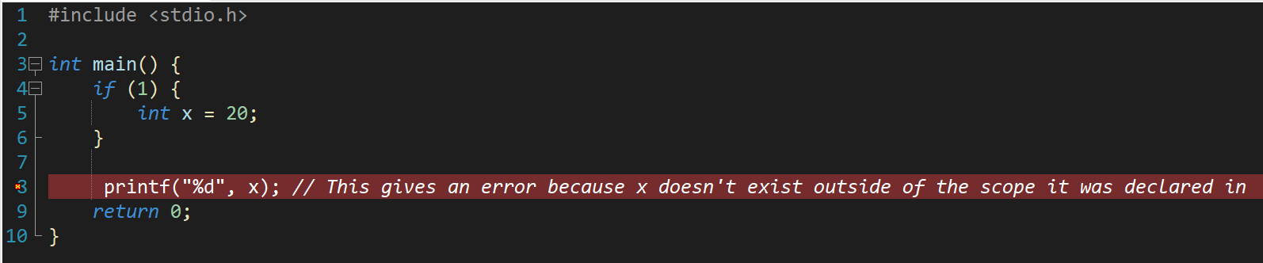
    - Python Code (Leaking Scope): 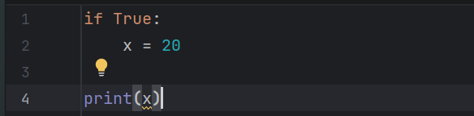
  - Semantics and Design Trade-offs: This comparison shows the trade-off between efficiency from static binding and flexibility from dynamic binding.
    - The Concepts:
      - C (Operational Focus): The semantics of C are closely tied to the machine state meaning that code in C gives direct instruction that causes changes in the computer’s hardware (memory and processor registers). The code does exactly what the hardware does so if the hardware register overflows so does the C variable.
      - Python (Denotational Semantics): Python abstracts the machine state to preserve the mathematical truth. Its semantics are defined by mathematical objects, so the meaning of ‘x + 1’ for example is the mathematical concept of addition and not a hardware instruction.
    - The Design Trade-off:
      - C: Prioritises efficiency as it accepts incorrect math (overflow) because it takes extra CPU cycles to check for it.
      - Python: Prioritises reliability and abstraction as it guarantees the correct mathematical result but has a high cost in performance from managing the dynamic memory.
    - C Implementation: 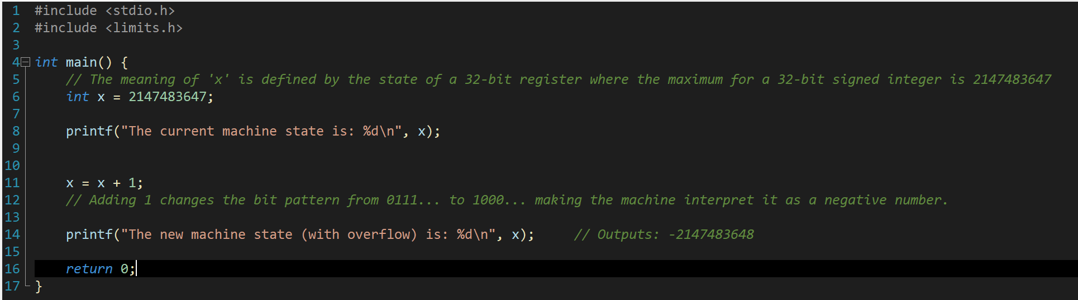
    - Python Implementation: 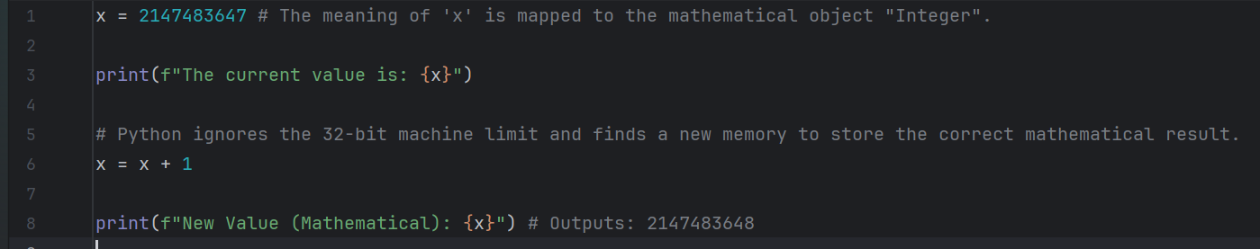
2.3 Prototype Implementation.
This prototype ‘list expansion prototype.c’ implements Python’s automatic memory management using C. In Python, when an item is appended to a list the list’s size is automatically increased to accommodate that item, but in C, the size of the list (array) is specified immediately so if the list is full a new item cannot be added. This prototype simulates how Python increases the size of its list after an item has been added.
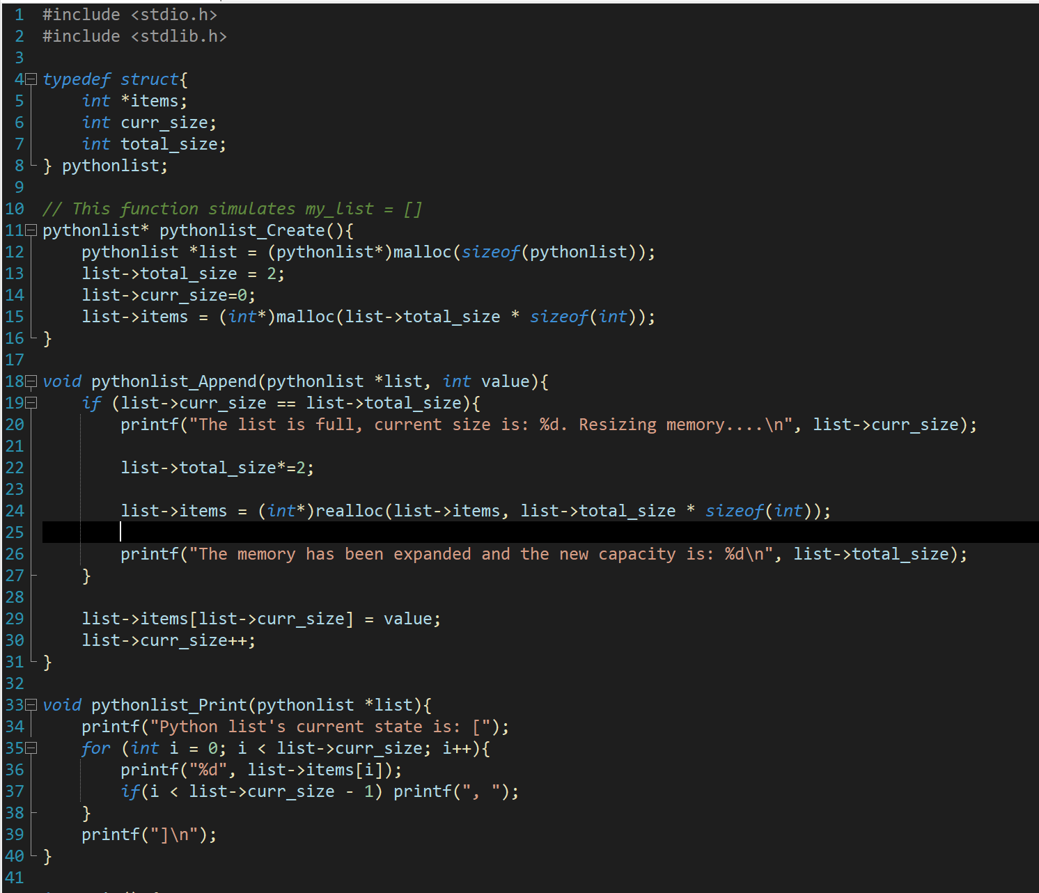
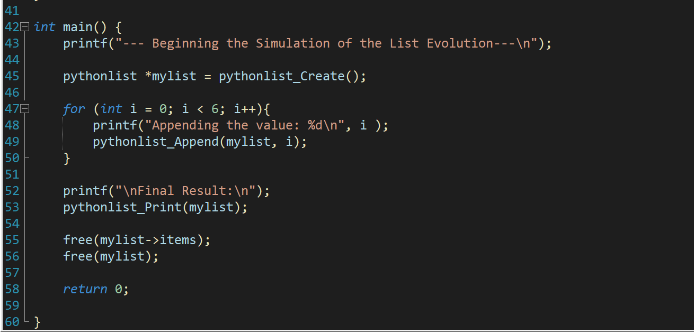

- Results and Discussion
3.1 Prototype Comparison
Parameter. | C Prototype | Python Implementation
code | 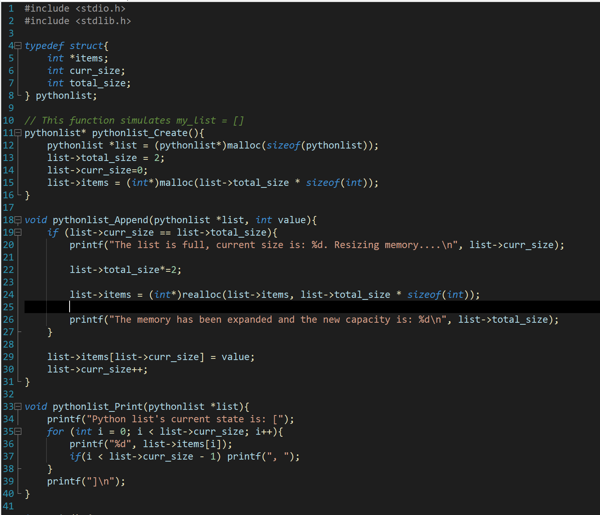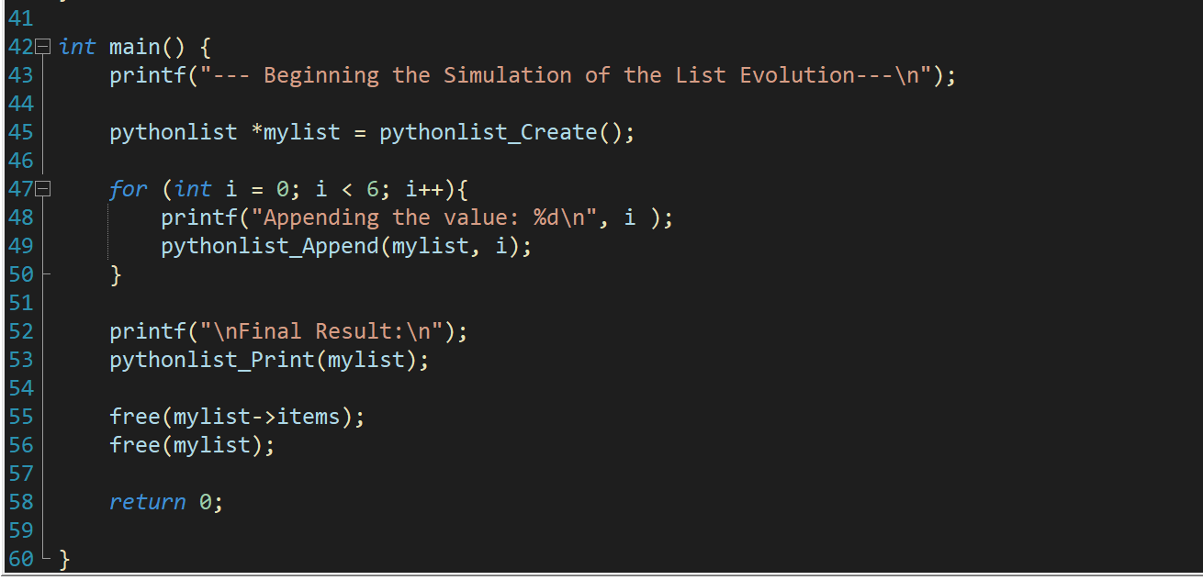 | 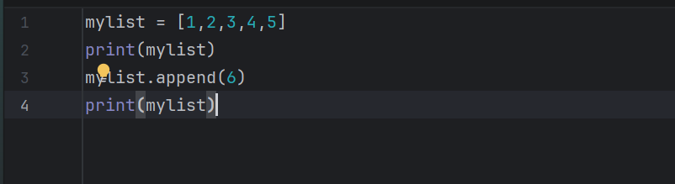
Output | 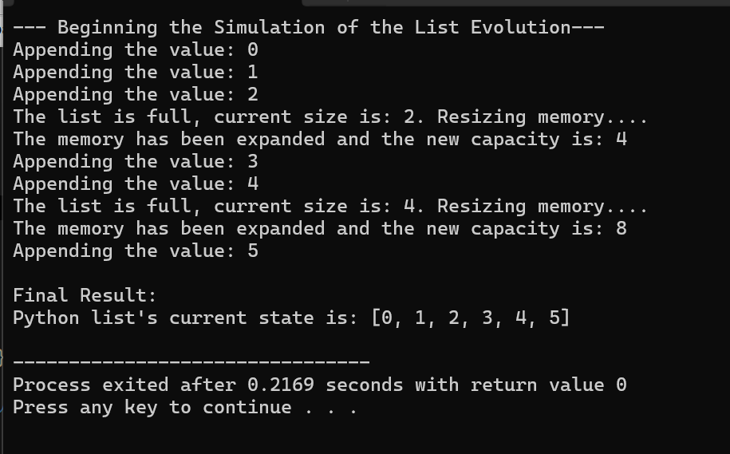 | 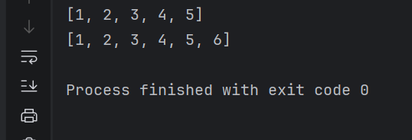

3.2 Data Types: Explicit vs. Implicit Declaration
- C (Explicit Declaration): C requires the programmer to explicitly declare the variable’s data type (e.g., int x = 20) thus it is bound at compile time. Attempting to assign a string literal to a variable declared as an integer will result in a syntax error because the type is a fixed property of the variable container itself.
- 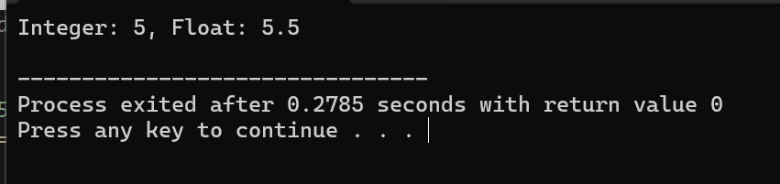
- Python (Implicit Declaration): Python does not require explicit declaring of data type, instead the data type of the variable is inferred from the value assigned to it(e.g., ‘x = 20’ infers ‘int’). This means that x can be reassigned to a string later because the type is dynamic and bound to the value and not the variable. 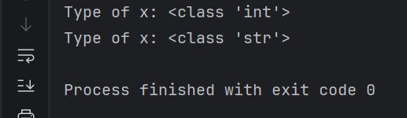
3.3 Variable Binding and Lifetime
- C (Stack-Dynamic lifetime): In C, local variables like those within a function are stack-dynamic and have their storage bound when the declaration is reached during execution and unbound when the code block ends. In the code snippet the variable inside the ‘if’ block became inaccessible after the closing brace.
- Python (Implicit Heap-Dynamic Lifetime): In Python by the interpreter manages allocation and deallocation of memory (garbage collection). For example, a variable ‘y = [1, 2]’ is created in a heap and its lifetime lasts for as long as there is a valid reference to it. 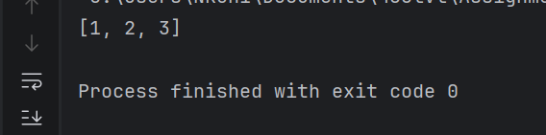
3.4 Scope Rules: Block vs. Lexical Scope
- C (Strict Block Scope): Variables in C that are declared inside a block (i.e., {…}) can only be seen within that block. Thus, accessing them outside of their scope will cause an “undeclared identifier” error.
- Python (Static/Lexical Scope with Leaking): Python uses static (lexical) scoping where the structure is determined by the program text but unlike C, Python does not have restrictions on the scope of variables declared in control structures like ‘if’ and ‘for’. A variable that is declared inside an ‘if’ block “leaks” into the surrounding function scope which makes it still accessible after the block has finished executing. 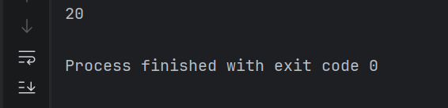
3.5 Semantics and Design Trade-offs
- Efficiency vs. Flexibility: C’s use of static binding fixes the data type of a variable before execution this focuses on efficiency, resolving types and memory offsets at compile time. Python’s dynamic binding determines the variable’s datatype at runtime which allows for flexibility but has the high cost of runtime type checking and interpretation.
  - C: 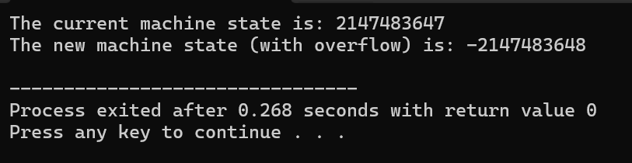
  - Python: 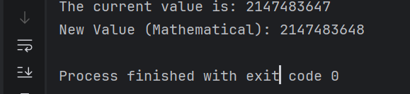
- Semantic Description: In operational semantics the meaning of a C statement is defined by its change in the machine state’s memory or registers. These machine level changes are abstracted in Python aligning it closer to Denotational semantics which focuses in the mapping of inputs to outputs rather than steps of execution.
3.6 Language Design Philosophy
The philosophy of programming languages has changed over the last few decades.
- The Philosophy of C: “Trust the Programmer”. C was designed in a period where hardware resources were scarce and expensive. Its philosophy is rooted in Operational Semantics as the language acts as a thin layer over the machine architecture.
    - Control over Abstraction: C prioritises efficiency by enforcing static binding and manual memory management.
    - Desing Intent: The language assumes the programmer knows what they are doing so it allows “unsafe” operations like integer overflow or pointer arithmetic because preventing them would cost the machine valuable CPU cycles to process them. The goal is to maximise hardware performance.
- The philosophy of Python: “Readability is important”. Python was designed in a period where human time was more expensive than hardware power. It aligns with Detotaional semantics as it treats code as a representation of abstract logic instead of machine intrustions.
    - Productivity over Performance: Python prioritises flexibility and developer speed by using dynamic binding and implicit heap-dynamic features.
    - Design Intent: The language assumes that the programmer prefers convenience as it automates complex tasks like memory management, reducing cognitive load. Its goal is to maximise the productivity of the human (programmer) using it.
In summary, the evolution of C to Python shows a transition from optimising for the machine to optimising for the mind.
4. Reflection
Studying the evolution from C to Python has affected my programming approach. It has made me understand that Python’s ease comes with a cost in performance like everytime I append to a list Python might be performing a realloc operation behind the scenes. This is highly relevant to current trends in AI and Data Sciences. While Python acts as the interface for AI because of its simplicity, the heavy lifting (e.g TensorFlow) is written in C/C++ for performance. This study shows that a complete software engineer must understand both the high-level design (Python) and the low-level mechanics (C).
5. Conclusion
The comparison of C and Python shows the trade-off of control for convenience. Through static binding and manual memory management, C gives the control necessary for system efficiency. Python, on the other hand, provides the abstraction necessary for developer efficiency using dynamic binding and automatic garbage collection. The prototype proves that features like dynamic lists can be created using C although they require complex logic to implement. At the end of the day, language evolution moves towards hiding this complexity to allow developers better solve higher level problems.

